

Boston University
College of Engineering
Mechanical Engineering Department

ME303 Fluid Mechanics
Laboratory Exercise No. 3:

FRICTION LOSS IN PIPES

GTF Instructor Manual

Spring 2009 Revision
Revision History

Name | Date | Notes
Keithe Baggett | May 2009 | Original Document

Setting up the System

- Turn on the switch for the system, located on the front of the tank apparatus. Flipping it to the up position turns the system on. You will hear the system begin to fill with water as the pump starts to cycle the water from the supply tank (lower tank) to the constant head tank (upper) tank.
- To ensure that the upper tank is being filled, open the green valve fully. When the water approaches the overflow drain, adjust the green valve to a lower flowrate and make sure that the water in the upper tank remains at a constant height as some water flows down the overflow drain into the lower supply tank.
- There are three flowmeters to be used in this lab – small, medium and large as is evident in Figure 1. Check that they are all sitting with no flow (zero percent flowrate) to start.
- Ensure that the Return Pipe drain is immersed in the supply tank and that it is completely full of water with no allowance for air bubbles. If this is not the case, first open the air bleed valve located at the top right of the system to release any initial air bubbles. Close the bleed valve when it sounds like it has finished releasing.
- Next, open one of the large pipes; the third pipe from the top in Figure 1 is shown as being connected to flow control valve number 15. Opening this pipe usually works well for this purpose due to its large diameter. (To open a pipe, one must open both valves on either end of the pipe).
- Increase the flow on the large flowmeter to its maximum. This process may take a few minutes while you wait for the Return Pipe to fill completely with water. If there are air bubbles stuck in the system that do not seem to be depositing into the supply tank, gently adjust the pipe by holding it straight and upwards. This eases the path to the bottom tank. The air bubbles have been found to contribute to incorrect pressure readings on the manometers, as well as considerably reduce the maximum flowrate, specifically for the small and large flowmeters.
- Be sure to let the Return Pipe fill entirely. Do not open the air bleed valve after filling the pipe because it acts as a vacuum since the reference pressure is then the bottom tank – this actually inserts air into the stream, which should certainly be avoided. If this happens, the system just needs to be filled with water again. Refer to steps 5-6.
- Bring all of the flowmeters back to zero, then check the system by individually opening the flowmeters to see if they reach their maximum values as indicated in the calibration pages of the manual.

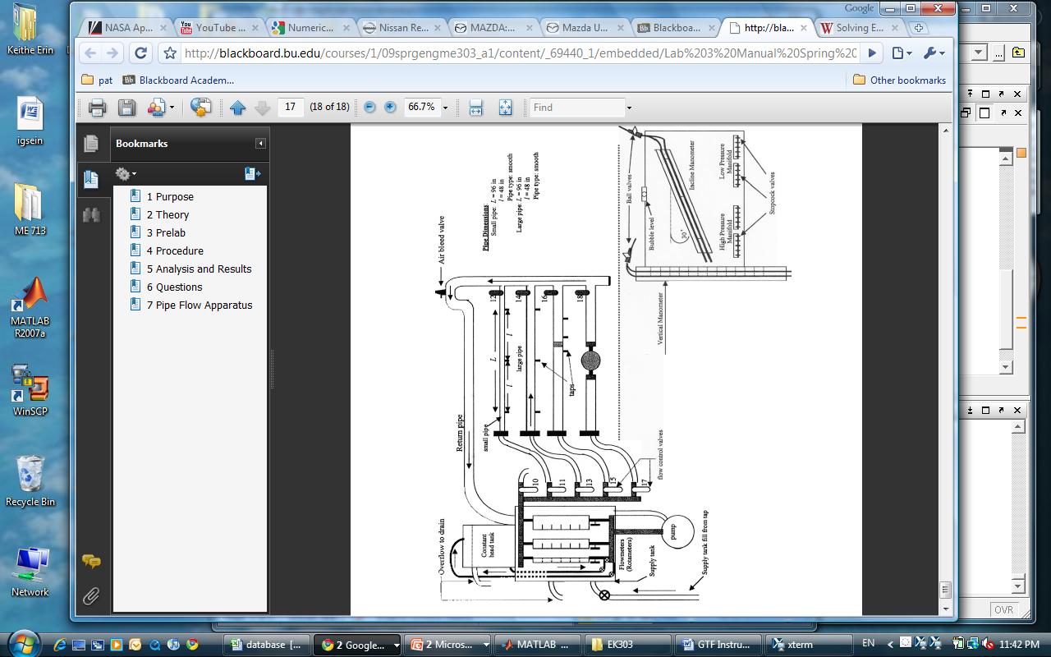
Figure 1: Pipe Flow System Schematic
Calibration

- In order to calibrate the system, both the incline and vertical manometers must be assessed. There are two tables to be used in the lab – Table 1 (Small Pipe) and Table 2 (Large Pipe). Table 1 uses the Small Flowmeter (which employs the incline manometer) and the Medium Flowmeter (which employs the vertical manometer). Table 2 uses the Medium Flowmeter (employing the incline manometer) and the Large Flowmeter (employing the vertical manometer).
- Beginning with the vertical manometer, at zero flow, ensure that the vertical manometer taps on the manifold are open as well as one of the full length pipes. (It shouldn’t matter which is used – large or small). One may open the stock-cock valve and use the bleed ports on the manifold to obtain values for low and high pressures that are within .2cm of being equal. Ideally, these values should be midway between the top and bottom of the manifold, around 150 to 160cm.
- The incline manometer has a similar procedure. Simply switch the ports on the manifold from vertical to incline manometer, while keeping the ports for one of the pipes open. With no flow, adjust the stock-cock valve and the bleed ports on the manifold to obtain values for low and high pressures that are within .2cm of being equal. Again, these values will ideally be midway between the top and bottom of the manifold, around 28 to 31cm.
- It often takes a few minutes for these manometers to settle to these pressure values that are so close to each other (negligible pressure difference). Once the lines appear settled and if the values are still far apart, one might shake the tubes connecting the manifold to the pipes in case there are air bubbles affecting the readings.
- Check that the system is operating favorably by taking the first few readings. For example, the following table was created using the Small Pipe with the Small Flowmeter, therefore employing the inclined manometer. This is done by setting all the flowmeters back to zero initially and adjusting the small flowmeter according to the setting provided. Make sure to change the ports as is necessary, switching from full length to upstream to downstream.
Small Pipe, Small Flowmeter
Setting | Full Length |  |  | Upstream |  |  | Downstream
 | High | Low | Diff_P | High | Low | Diff_P | High | Low | Diff_P
0 | 27.7 | 27.7 | 0 | 27.5 | 27.5 | 0 | 26.8 | 26.8 | 0
10 | 27.9 | 26.4 |  | 27.9 | 26.8 |  | 27.2 | 26.3
16 | 28.3 | 25.8 |  | 28.1 | 26.5 |  | 27.4 | 25.9

- Note that the high pressures will increase gradually, while the low pressures will decrease. Differential pressures are calculated during the lab write-up.
- Check the system again by returning all flowmeters back to zero and watching as the pressure values return to the calibrated values.

